Chapter 2
Requirement Specification and Analysis
Requirements analysis is a process of determining user expectations for a new or modified product. These features, called requirements, must be quantifiable, relevant, and detailed. In software engineering, such requirements are often called functional specifications. In Chapter 2, we will enlist the functional and non-functional requirements for the Hybrid AI-IoT System and model the functional requirements in the form of a use case model.
2.1. Functional Requirements:
A functional requirement defines a function of a system or its component. Functional requirements may be calculations, technical details, data manipulation and processing, and other specific functionality that define what a system is supposed to accomplish. For our system, this includes sensor data processing, rule-based risk evaluation, and AI-based disease confirmation.
Table 2.1: Functional Requirements

No. | Functional Requirement | Type | Status
1. | Farmers should be able to register their accounts. | Core | Pending
2. | Farmers should be able to log in to their accounts. | Core | Pending
3. | Farmers should be able to update their profile. | Intermediate | Pending
4. | Farmers should be able to reset their passwords. | Core | Pending
5. | Farmers should be able to log out of their accounts. | Core | Pending
6. | Farmers should be able to switch languages between Urdu and English. | Core | Pending
7. | Farmers should be able to connect the sensors with the  portal via Bluetooth or Wi-Fi. | Core | Pending
8. | Farmers should be able to view the readings of the sensors. | Core | Pending
9. | Farmers should be able to compare the readings with the threshold. | Core | Pending
10. | Farmers should be able to see the details of the predicted disease. | Core | Pending
11. | Farmers should be able to verify disease by uploading crop images through the web interface. | Core | Pending
12. | Farmers should be able to view the detected disease result on the web portal | Core | Pending
13. | Farmers should be able to see the severity level of the detected disease. | Core | Pending
14. | Farmers should be able to see the treatment recommendation for the detected disease. | Core | Pending
15. | Farmers should be able to view all received alerts in a notification list with timestamps. | Core | Pending
16. | Farmers should be able to view the history. | Intermediate | Pending
17. | Admin should be able to register the account. | Core | Pending
18. | Admin should be able to log in to the account. | Core | Pending
19. | Admin should be able to update profile information. | Intermediate | Pending
20. | Admin should be able to reset the password. | Core | Pending
21. | Admin should be able to log out of the admin panel. | Core | Pending
22. | Admin should be able to register the farmers. | Core | Pending
23. | Admin should be able to view and manage farmers' accounts. | Core | Pending
24. | Admin should be able to view sensor readings across all registered farms. | Core | Pending
25. | Admin should be able to view all alerts. | Core | Pending
26. | Admin should be able to filter data by farmer name. | Intermediate | Pending
27. | Admin should be able to view summary statistics. | Intermediate | Pending
28. | Admin should be able to view the history. | Intermediate | Pending
29. | Admin should be able to generate weekly or monthly reports. | Intermediate | Pending

2.2. Non-Functional Requirements
A non-functional requirement specifies criteria that can be used to judge the operation of a system, rather than specific behaviors. They are contrasted with functional requirements that define specific behavior or functions. For our Hybrid AI-IoT System, this includes ensuring sensor data accuracy, system reliability during network interruptions, platform scalability, and data security.

Table 2.2: Non-Functional Requirements
No. | Non-Functional Requirement | Category
1 | The system should ensure accurate data transfer from IoT sensors to the server database. | Accuracy
2 | The system should ensure data privacy and security for all farmer account details. | Security
3 | The system should have a simple and interactive user interface. | Usability
4 | The system should be scalable to support multiple farmers without performance degradation. | Scalability
5 | The system should be accessible at all times. | Availability
6 | The system should remain reliable during short signal interruptions and automatically reconnect without losing sensor data. | Reliability

2.4. System Use Case Modeling:

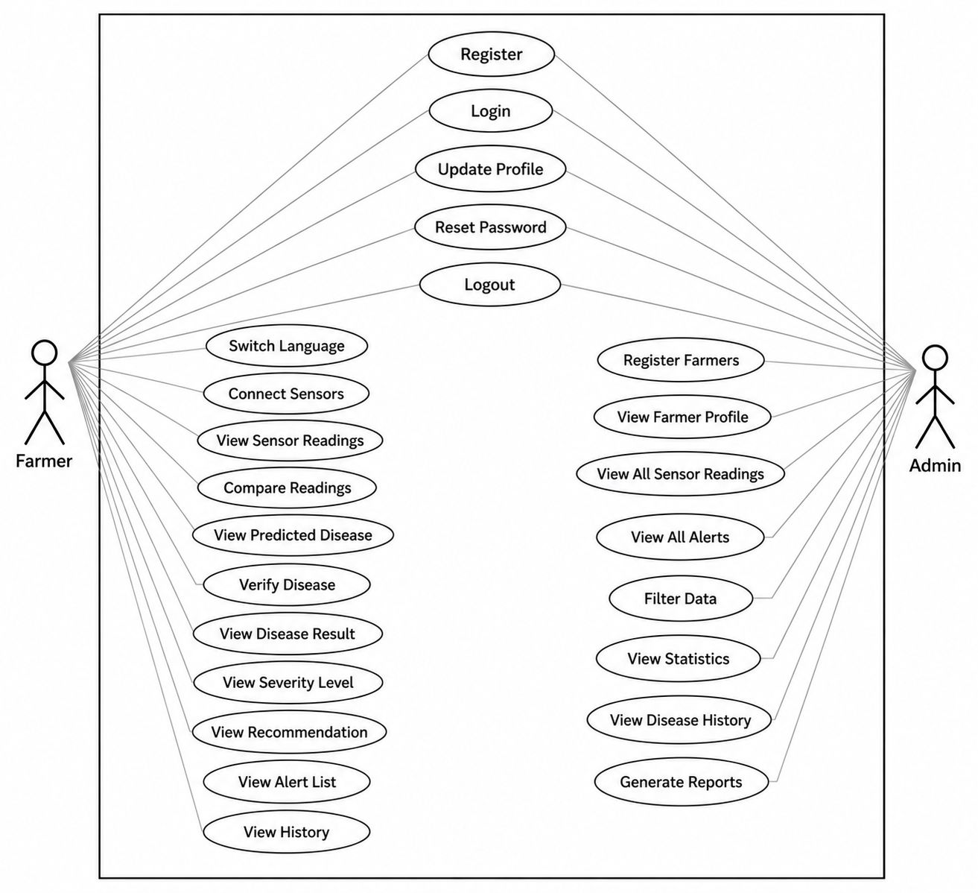

Use Case Descriptions

Use Case ID: | UC01
Use Case Name: | Register
Created By: | Rehan Javed | Last Updated By: | Talha Tariq
Date Created: | 15/04/2026 | Last Revision Date: | 01/05/2026
Actors: | Farmer, Admin
Description: | Allows users to create a new account by entering name, email, phone number, and password.
Trigger: | User clicks on Register.
Preconditions: | Internet connection active.
Postconditions: | New account created.
Normal Flow: | User |  | System
 | User selects role and clicks Register. |  | System displays registration form.
 | User enters details and clicks Submit. |  | System validates and saves account.
Alternative Flow: | If input is invalid or email exists, system shows error and returns to form.
Exceptions: | Duplicate email. Invalid input. Network failure.

Use Case ID: | UC02
Use Case Name: | Login
Created By: | Talha Tariq | Last Updated By: | Rehan Javed
Date Created: | 15/04/2026 | Last Revision Date: | 01/05/2026
Actors: | Farmer, Admin
Description: | Allows registered users to log in by entering email and password.
Trigger: | User clicks on Login.
Preconditions: | Internet connection active. User has a registered account.
Postconditions: | User is authenticated and redirected to dashboard.
Normal Flow: | User |  | System
 | User enters email and password. |  | System verifies credentials.
 | User clicks Login. |  | System redirects to appropriate dashboard.
Alternative Flow: | If credentials are wrong, system shows error and allows retry.
Exceptions: | Invalid credentials. Deactivated account. Network failure.

Use Case ID: | UC03
Use Case Name: | Update Profile
Created By: | Abdul Rauf | Last Updated By: | Rehan Javed
Date Created: | 16/04/2026 | Last Revision Date: | 01/05/2026
Actors: | Farmer, Admin
Description: | Allows users to update profile information such as name and phone number.
Trigger: | User navigates to Profile Settings.
Preconditions: | User is logged in.
Postconditions: | Profile information updated.
Normal Flow: | User |  | System
 | User clicks Profile Settings. |  | System displays current profile.
 | User edits fields and clicks Save. |  | System validates and saves changes.
Alternative Flow: | If input is invalid, system highlights error.
Exceptions: | Invalid input. Network failure.

Use Case ID: | UC04
Use Case Name: | Reset Password
Created By: | Talha Tariq | Last Updated By: | Abdul Rauf
Date Created: | 16/04/2026 | Last Revision Date: | 02/05/2026
Actors: | Farmer, Admin
Description: | Allows users to reset their password via registered email.
Trigger: | User clicks Forgot Password.
Preconditions: | User has a registered account with valid email.
Postconditions: | Password updated.
Normal Flow: | User |  | System
 | User clicks Forgot Password. |  | System shows reset form.
 | User enters email. |  | System sends reset link to email.
 | User clicks link and enters new password. |  | System updates the password.
Alternative Flow: | If email is not registered, system shows error.
Exceptions: | Unregistered email. Expired link. Network failure.

Use Case ID: | UC05
Use Case Name: | Logout
Created By: | Abdul Rauf | Last Updated By: | Talha Tariq
Date Created: | 17/04/2026 | Last Revision Date: | 02/05/2026
Actors: | Farmer, Admin
Description: | Allows users to log out of the system.
Trigger: | User clicks Logout.
Preconditions: | User is logged in.
Postconditions: | User session ended. Redirected to login page.
Normal Flow: | User |  | System
 | User clicks Logout. |  | System ends the session.
 |  |  | System redirects to login page.
Alternative Flow: | If the system fails to end the session due to a server error, the user is still redirected to the login page and the session expires automatically.
Exceptions: | Server error. Session already expired.

Use Case ID: | UC06
Use Case Name: | Switch Language
Created By: | Abdul Rauf | Last Updated By: | Rehan Javed
Date Created: | 17/04/2026 | Last Revision Date: | 02/05/2026
Actors: | Farmer
Description: | Allows farmer to switch portal language between Urdu and English.
Trigger: | Farmer clicks Language toggle.
Preconditions: | Farmer is logged in.
Postconditions: | Portal language switched.
Normal Flow: | User |  | System
 | Farmer clicks Language toggle. |  | System switches language.
 |  |  | System reloads content in selected language.
Alternative Flow: | If the selected language is already active, system takes no action.
Exceptions: | Page reload failure.

Use Case ID: | UC07
Use Case Name: | Connect Sensors
Created By: | Rehan Javed | Last Updated By: | Rehan Javed
Date Created: | 18/04/2026 | Last Revision Date: | 02/05/2026
Actors: | Farmer
Description: | Allows farmer to connect IoT sensors via Bluetooth or Wi-Fi.
Trigger: | Farmer clicks Connect on Sensor Setup page.
Preconditions: | Farmer is logged in. Sensors are powered on and within range.
Postconditions: | Sensors connected. Status shown as active.
Normal Flow: | User |  | System
 | Farmer opens Sensor Setup page. |  | System shows available sensors.
 | Farmer selects sensor and clicks Connect. |  | System pairs and connects sensor.
Alternative Flow: | If sensor is out of range or off, system shows connection failure.
Exceptions: | Sensor out of range. Bluetooth/Wi-Fi disabled.

Use Case ID: | UC08
Use Case Name: | View Sensor Readings
Created By: | Rehan Javed | Last Updated By: | Talha Tariq
Date Created: | 19/04/2026 | Last Revision Date: | 02/05/2026
Actors: | Farmer
Description: | Allows farmer to view on-demand readings from connected sensors.
Trigger: | Farmer clicks View Readings.
Preconditions: | Farmer is logged in. At least one sensor is connected.
Postconditions: | Sensor readings displayed.
Normal Flow: | User |  | System
 | Farmer clicks View Readings. |  | System fetches latest sensor data.
 |  |  | System displays humidity, temperature, and soil moisture values.
Alternative Flow: | If no sensor is connected, system displays a message asking the farmer to connect a sensor first.
Exceptions: | No sensor connected. Sensor not responding.

Use Case ID: | UC09
Use Case Name: | Compare Readings
Created By: | Talha Tariq | Last Updated By: | Rehan Javed
Date Created: | 20/04/2026 | Last Revision Date: | 03/05/2026
Actors: | Farmer
Description: | Allows farmer to compare sensor readings against disease threshold values.
Trigger: | Farmer clicks Compare with Thresholds.
Preconditions: | Sensor readings available. Thresholds configured.
Postconditions: | Comparison result displayed.
Normal Flow: | User |  | System
 | Farmer clicks Compare with Thresholds. |  | System retrieves readings and thresholds.
 |  |  | System runs rule engine and shows risk level.
Alternative Flow: | If sensor readings are not available, system displays a message asking the farmer to take readings first.
Exceptions: | Sensor readings not available. Thresholds not configured.

Use Case ID: | UC10
Use Case Name: | View Predicted Disease
Created By: | Abdul Rauf | Last Updated By: | Rehan Javed
Date Created: | 20/04/2026 | Last Revision Date: | 03/05/2026
Actors: | Farmer
Description: | Allows farmer to view details of the disease predicted by the rule engine.
Trigger: | Farmer clicks View Details on prediction.
Preconditions: | Threshold comparison performed. Disease risk identified.
Postconditions: | Disease details displayed.
Normal Flow: | User |  | System
 | Farmer clicks View Details. |  | System retrieves disease information.
 |  |  | System displays disease name, crop, and risk level.
Alternative Flow: | If disease information for the predicted disease is not found in the database, system displays the risk level without disease details
Exceptions: | Disease data not found.

Use Case ID: | UC11
Use Case Name: | Verify Disease
Created By: | Rehan Javed | Last Updated By: | Abdul Rauf
Date Created: | 21/04/2026 | Last Revision Date: | 03/05/2026
Actors: | Farmer
Description: | Allows farmer to verify predicted disease by uploading a leaf image for CNN classification.
Trigger: | Farmer clicks Verify Disease.
Preconditions: | Farmer is logged in. Camera or image available.
Postconditions: | CNN classification result generated.
Normal Flow: | User |  | System
 | Farmer clicks Verify Disease. |  | System opens image upload.
 | Farmer uploads leaf image. |  | System classifies image via CNN.
 |  |  | System displays disease name and confidence score.
Alternative Flow: | If image is unclear, system asks farmer to retake photo.
Exceptions: | Invalid image. Model processing error.
..

Use Case ID: | UC12
Use Case Name: | View Disease Result
Created By: | Talha Tariq | Last Updated By: | Rehan Javed
Date Created: | 22/04/2026 | Last Revision Date: | 03/05/2026
Actors: | Farmer
Description: | Allows farmer to view the detected disease result after CNN classification.
Trigger: | CNN classification is completed.
Preconditions: | Disease classification has been performed.
Postconditions: | Disease result displayed.
Normal Flow: | User |  | System
 | Farmer views the detection screen. |  | System applies decision fusion on sensor and CNN results.
 |  |  | System displays the final disease name and crop affected.
Alternative Flow: | If only one result is available (sensor or CNN but not both), system displays the available result without fusion.
Exceptions: | No detection results available. Processing error.

Use Case ID: | UC13
Use Case Name: | View Severity Level
Created By: | Abdul Rauf | Last Updated By: | Talha Tariq
Date Created: | 22/04/2026 | Last Revision Date: | 03/05/2026
Actors: | Farmer
Description: | Allows farmer to view the severity level of the detected disease.
Trigger: | Disease result is displayed.
Preconditions: | Disease detection completed.
Postconditions: | Severity level displayed.
Normal Flow: | User |  | System
 | Farmer views disease result page. |  | System calculates severity based on disease type and conditions.
 |  |  | System displays severity level (Low, Moderate, or Severe).
Alternative Flow: | If environmental data is insufficient for severity calculation, system displays the disease result without severity level.
Exceptions: | Insufficient environmental data. Disease not recognized.

Use Case ID: | UC14
Use Case Name: | View Recommendation
Created By: | Rehan Javed | Last Updated By: | Talha Tariq
Date Created: | 23/04/2026 | Last Revision Date: | 03/05/2026
Actors: | Farmer
Description: | Allows farmer to view treatment recommendation for the detected disease.
Trigger: | Disease result and severity are displayed.
Preconditions: | Disease detection and severity calculation completed.
Postconditions: | Treatment recommendation displayed.
Normal Flow: | User |  | System
 | Farmer views disease result page. |  | System retrieves recommendation for the disease and crop.
 |  |  | System displays treatment recommendation.
Alternative Flow: | If no specific recommendation exists for the detected disease, system displays a message.
Exceptions: | Recommendation data not found.

Use Case ID: | UC15
Use Case Name: | View Alert List
Created By: | Abdul Rauf | Last Updated By: | Rehan Javed
Date Created: | 23/04/2026 | Last Revision Date: | 03/05/2026
Actors: | Farmer
Description: | Allows farmer to view all disease alerts and risk notifications.
Trigger: | Farmer clicks Alerts icon.
Preconditions: | Farmer is logged in.
Postconditions: | Alert list displayed.
Normal Flow: | User |  | System
 | Farmer clicks Alerts icon. |  | System retrieves alerts.
 |  |  | System displays alerts with timestamps and status.
 | Farmer clicks on an alert. |  | System shows details and marks as read.
Alternative Flow: | If no alerts exist, system shows empty state message.
Exceptions: | Database retrieval failure.

Use Case ID: | UC16
Use Case Name: | View History
Created By: | Talha Tariq | Last Updated By: | Abdul Rauf
Date Created: | 24/04/2026 | Last Revision Date: | 03/05/2026
Actors: | Farmer
Description: | Allows farmer to view past sensor readings, detections, and recommendations.
Trigger: | Farmer clicks History.
Preconditions: | Farmer is logged in. Historical data exists.
Postconditions: | History records displayed.
Normal Flow: | User |  | System
 | Farmer clicks History. |  | System retrieves historical records.
 |  |  | System displays past records with dates and details.
Alternative Flow: | If no records exist, system shows empty state message.
Exceptions: | Database retrieval failure.

Use Case ID: | UC17
Use Case Name: | Register Farmers
Created By: | Rehan Javed | Last Updated By: | Abdul Rauf
Date Created: | 25/04/2026 | Last Revision Date: | 03/05/2026
Actors: | Admin
Description: | Allows admin to register farmer accounts.
Trigger: | Admin clicks Register New Farmer.
Preconditions: | Admin is logged in.
Postconditions: | Farmer account created.
Normal Flow: | User |  | System
 | Admin clicks Register New Farmer. |  | System displays farmer registration form.
 | Admin enters farmer's details and clicks Submit. |  | System validates and creates the farmer account.
Alternative Flow: | If farmer email already exists, system shows duplicate error.
Exceptions: | Duplicate email. Invalid input. Network failure.

Use Case ID: | UC18
Use Case Name: | View Farmer Profile
Created By: | Talha Tariq | Last Updated By: | Rehan Javed
Date Created: | 25/04/2026 | Last Revision Date: | 03/05/2026
Actors: | Admin
Description: | Allows admin to view the profile details of a registered farmer.
Trigger: | Admin clicks on a farmer's name from the farmer list.
Preconditions: | Admin is logged in. Farmer account exists.
Postconditions: | Farmer profile displayed.
Normal Flow: | User |  | System
 | Admin opens farmer list. |  | System displays list of registered farmers.
 | Admin clicks on a farmer's name. |  | System displays farmer's profile details.
Alternative Flow: | If farmer account has been deactivated, system shows deactivated status.
Exceptions: | Farmer data not found.

Use Case ID: | UC19
Use Case Name: | View All Sensor Readings
Created By: | Abdul Rauf | Last Updated By: | Talha Tariq
Date Created: | 26/04/2026 | Last Revision Date: | 03/05/2026
Actors: | Admin
Description: | Allows admin to view sensor readings across all registered farms.
Trigger: | Admin clicks Sensor Readings on admin panel.
Preconditions: | Admin is logged in. Sensor data exists.
Postconditions: | All sensor readings displayed.
Normal Flow: | User |  | System
 | Admin clicks Sensor Readings. |  | System retrieves readings from all farms.
 |  |  | System displays readings grouped by farmer and farm.
Alternative Flow: | If no sensor data exists, system shows empty state message.
Exceptions: | Database retrieval failure.

Use Case ID: | UC20
Use Case Name: | View All Alerts
Created By: | Rehan Javed | Last Updated By: | Abdul Rauf
Date Created: | 26/04/2026 | Last Revision Date: | 03/05/2026
Actors: | Admin
Description: | Allows admin to view all alerts generated across all farms.
Trigger: | Admin clicks Alerts on admin panel.
Preconditions: | Admin is logged in.
Postconditions: | All alerts displayed.
Normal Flow: | User |  | System
 | Admin clicks Alerts. |  | System retrieves all alerts from all farms.
 |  |  | System displays alerts with farmer name, timestamp, and status.
Alternative Flow: | If no alerts exist, system shows empty state message.
Exceptions: | Database retrieval failure.

Use Case ID: | UC21
Use Case Name: | Filter Data
Created By: | Talha Tariq | Last Updated By: | Rehan Javed
Date Created: | 27/04/2026 | Last Revision Date: | 03/05/2026
Actors: | Admin
Description: | Allows admin to filter data by farmer name.
Trigger: | Admin enters a farmer name in the filter field.
Preconditions: | Admin is logged in. Data exists in system.
Postconditions: | Filtered data displayed.
Normal Flow: | User |  | System
 | Admin enters farmer name in filter field. |  | System searches records matching the name.
 |  |  | System displays filtered results.
Alternative Flow: | If no matching records are found, system displays a no results message.
Exceptions: | Database retrieval failure. Network failure

Use Case ID: | UC22
Use Case Name: | View Statistics
Created By: | Abdul Rauf | Last Updated By: | Rehan Javed
Date Created: | 27/04/2026 | Last Revision Date: | 03/05/2026
Actors: | Admin
Description: | Allows admin to view summary statistics of the system.
Trigger: | Admin clicks Statistics on admin panel.
Preconditions: | Admin is logged in. Sufficient data exists.
Postconditions: | Summary statistics displayed.
Normal Flow: | User |  | System
 | Admin clicks Statistics. |  | System calculates summary data.
 |  |  | System displays total farmers, detections, alerts, and sensor averages.
Alternative Flow: | If no data exists yet, system displays zero values with a message that statistics will appear after data is collected.
Exceptions: | Database retrieval failure.

Use Case ID: | UC23
Use Case Name: | View Disease History
Created By: | Rehan Javed | Last Updated By: | Talha Tariq
Date Created: | 28/04/2026 | Last Revision Date: | 03/05/2026
Actors: | Admin
Description: | Allows admin to view disease detection history across all farms.
Trigger: | Admin clicks Disease History on admin panel.
Preconditions: | Admin is logged in. Disease records exist.
Postconditions: | Disease history displayed.
Normal Flow: | User |  | System
 | Admin clicks Disease History. |  | System retrieves all disease records.
 |  |  | System displays disease history with farmer, crop, disease, date, and severity.
Alternative Flow: | If no disease records exist, system shows empty state message.
Exceptions: | Database retrieval failure.

Use Case ID: | UC24
Use Case Name: | Generate Reports
Created By: | Talha Tariq | Last Updated By: | Rehan Javed
Date Created: | 28/04/2026 | Last Revision Date: | 03/05/2026
Actors: | Admin
Description: | Allows admin to generate weekly or monthly summary reports.
Trigger: | Admin clicks Generate Report.
Preconditions: | Admin is logged in. Data exists for selected period.
Postconditions: | Report generated and displayed.
Normal Flow: | User |  | System
 | Admin clicks Generate Report. |  | System shows report options.
 | Admin selects period and clicks Generate. |  | System generates report.
 |  |  | System displays report with download option.
Alternative Flow: | If no data exists, system displays a message that the report cannot be generated for the selected time period.
Exceptions: | No data for selected period. Report timeout.

2.5. System Sequence diagram:
Farmer SSD:
A System Sequence Diagram (SSD) illustrates how the Farmer interacts with the Hybrid AI-IoT System during a specific use-case scenario. It shows the sequence of messages exchanged between the actor (Farmer) and the system (such as viewing sensor readings, receiving early warnings, or uploading leaf images), along with how the system responds.

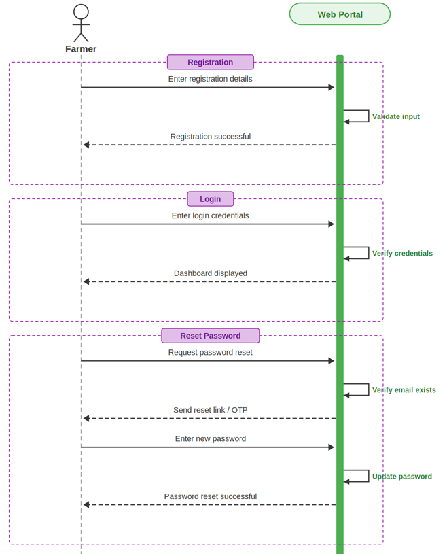
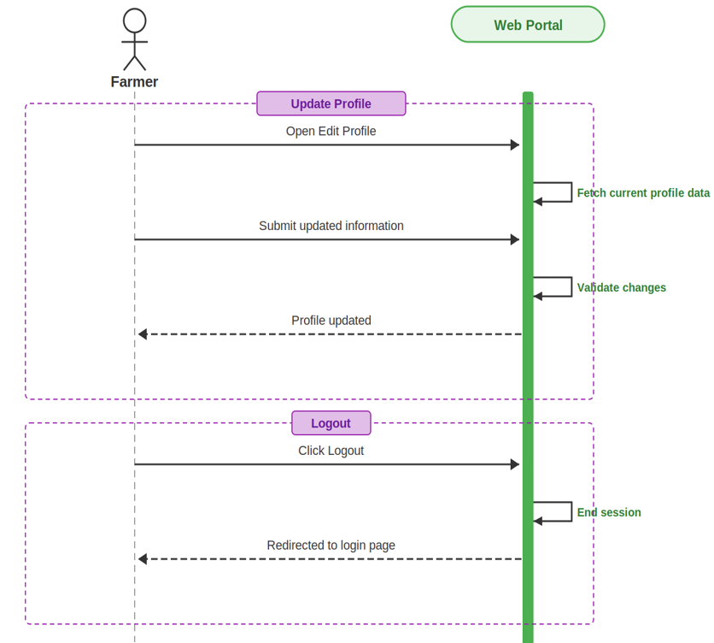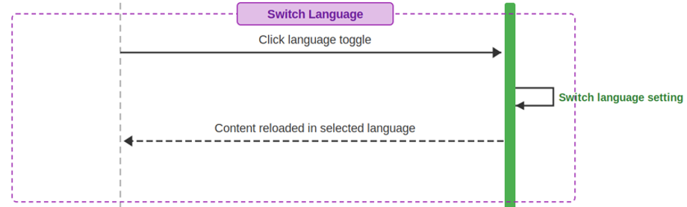
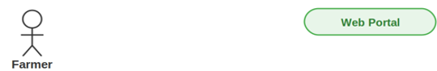
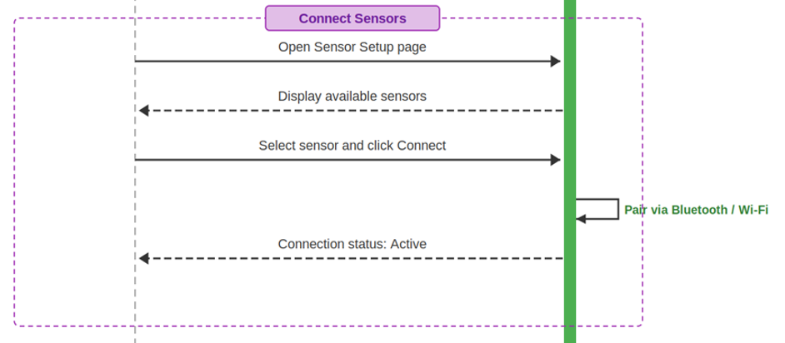
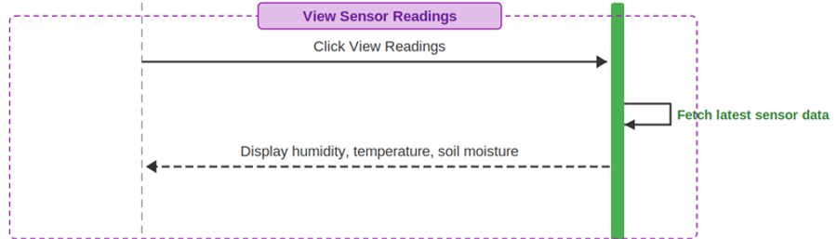
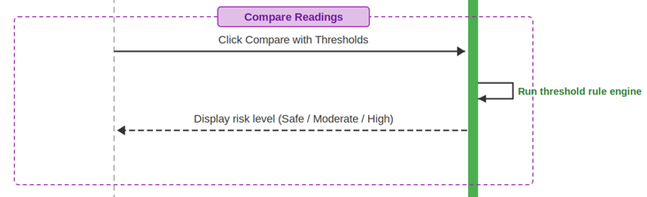
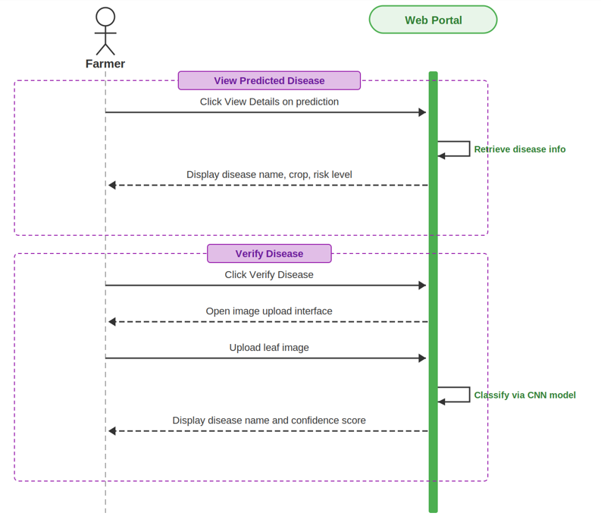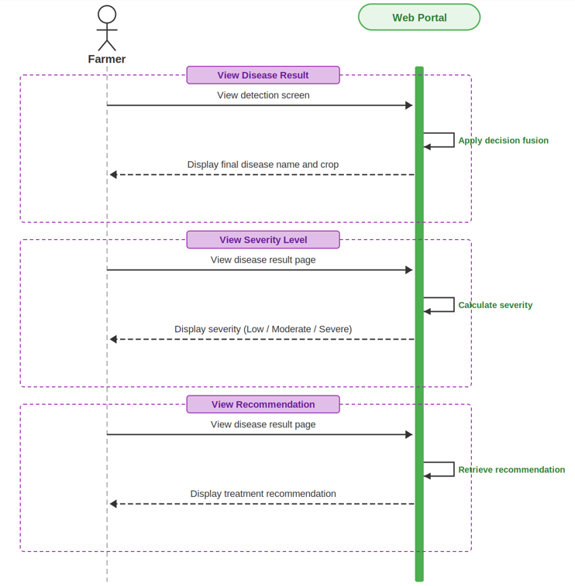
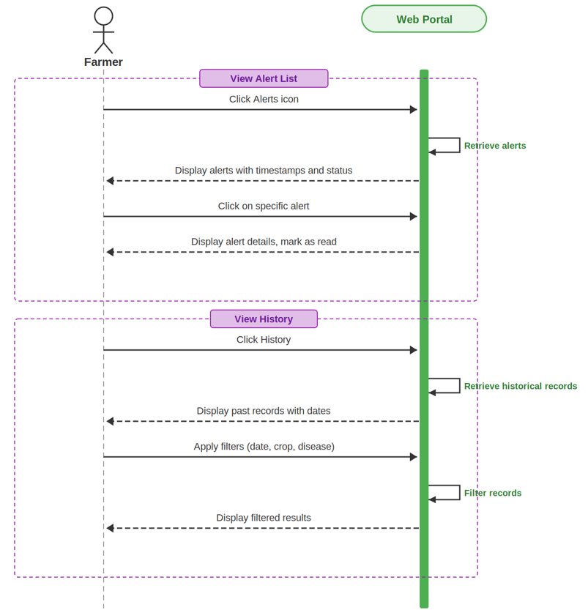

Admin SSD: A System Sequence Diagram (SSD) illustrates how the Admin interacts with the Hybrid AI-IoT System during a specific use-case scenario. It shows the sequence of messages exchanged between the actor (Admin) and the system (such as managing farmer profiles, viewing system-wide sensor readings, or generating regional statistical reports), along with how the system responds.
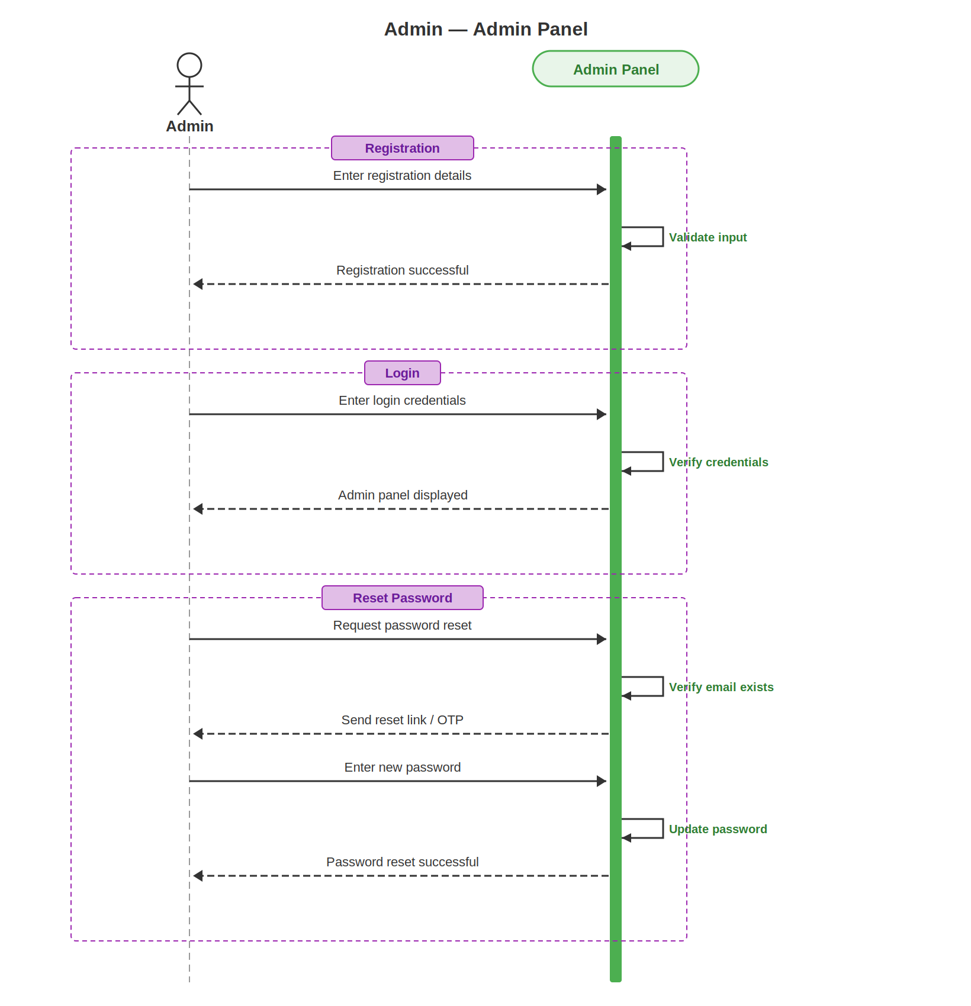
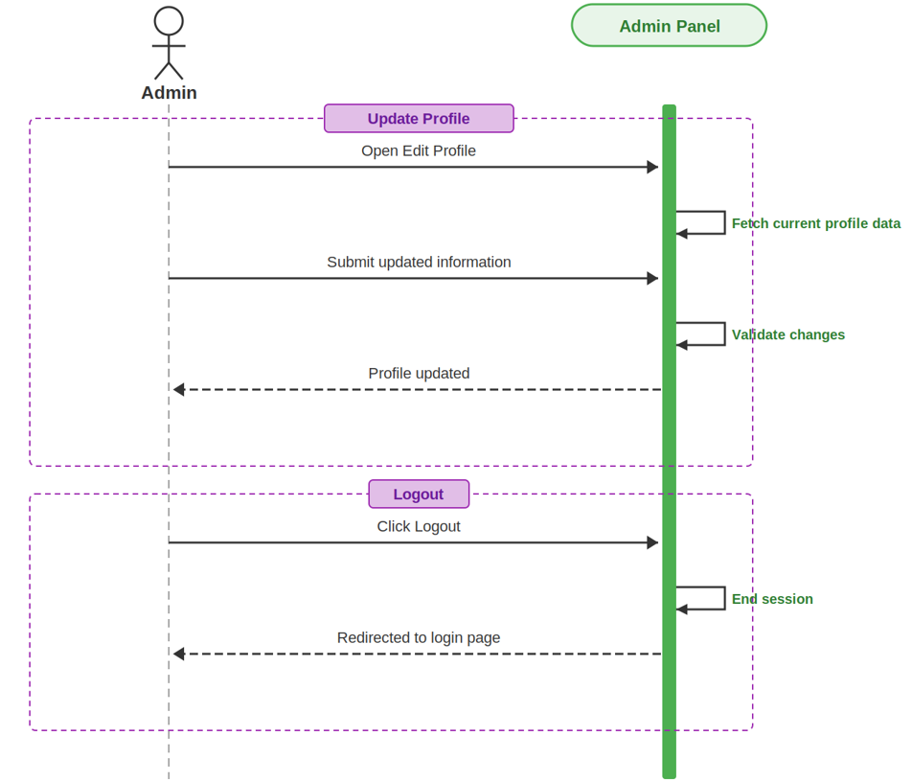

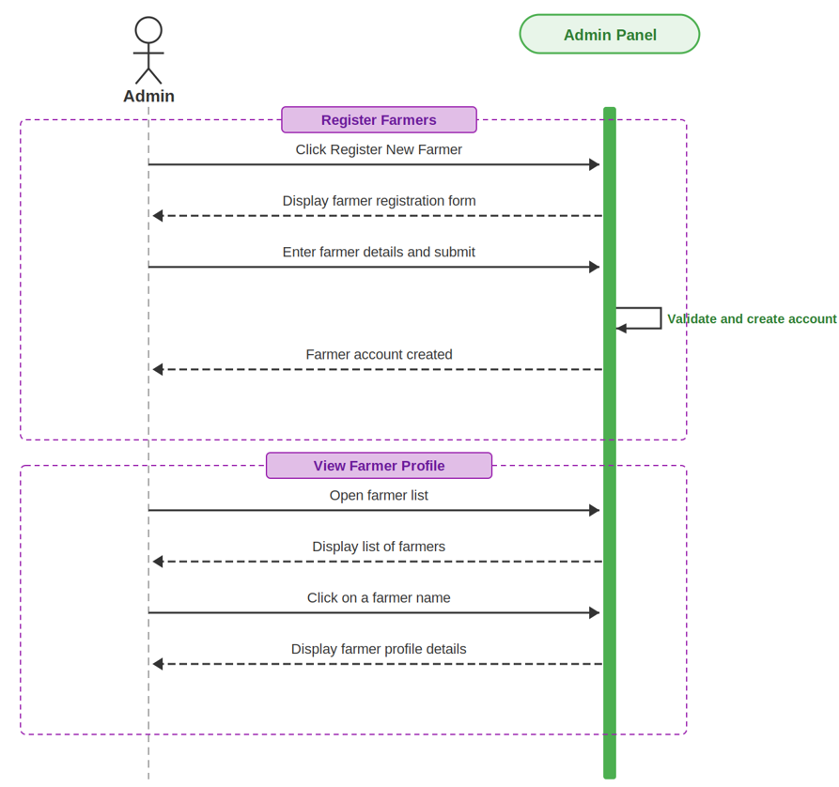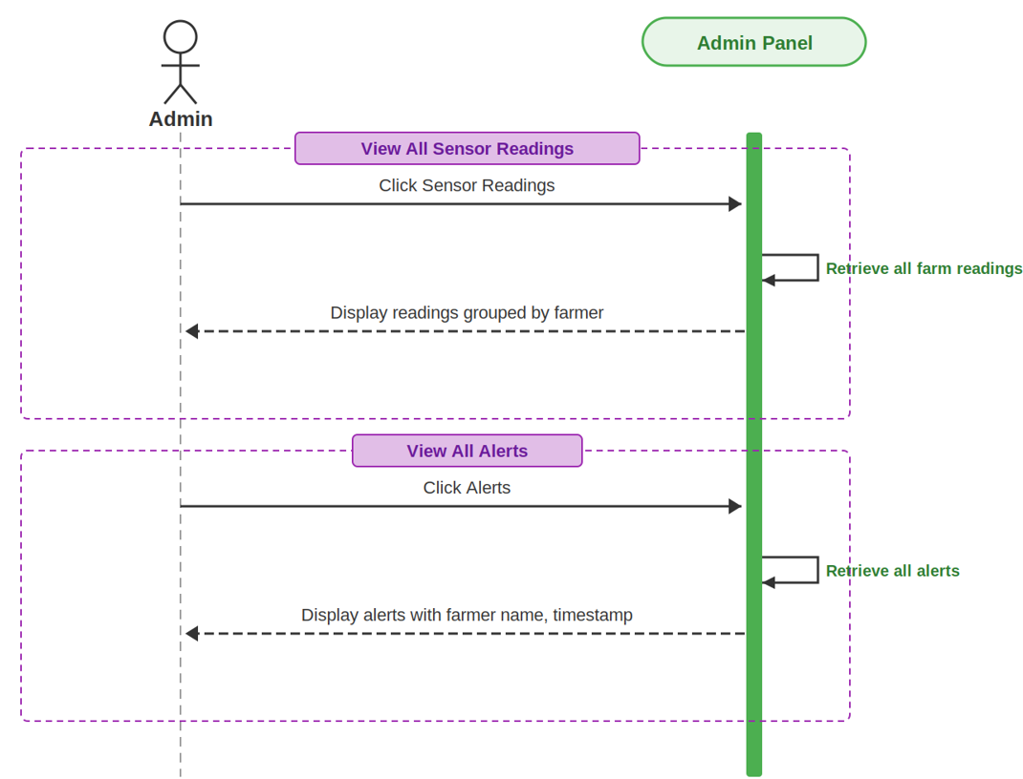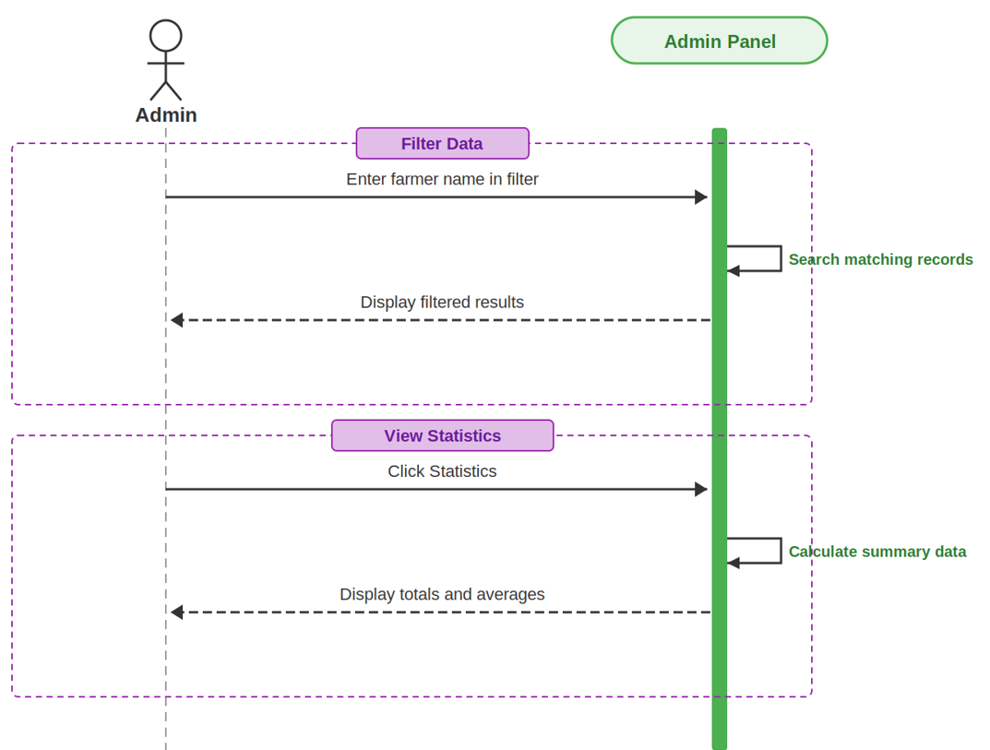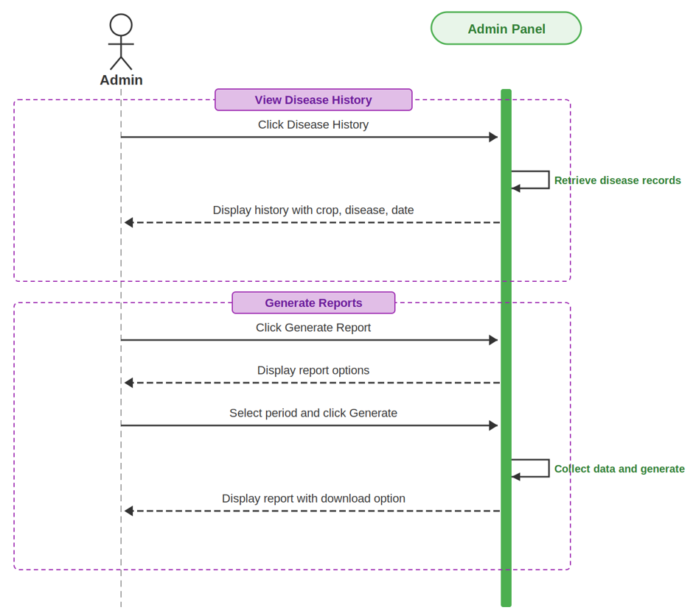

2.6. Domain Model: The basic concepts of the domain for this system are Farmer, Admin, Farm, Crop, IoT Sensor, Sensor Reading, Disease Threshold, Disease Diagnosis, Alerts, and Reports, as shown in the following figure representing the domain model.

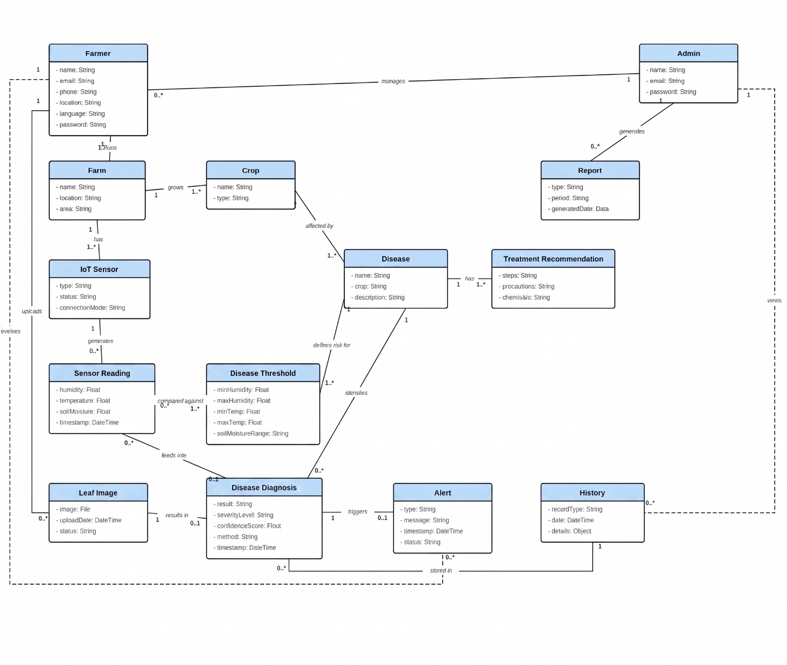

Chapter 3
System Design
The purpose of this chapter is to provide information that is complementary to the development phase. Without an adequate design that delivers required functions as well as quality attributes, the project will fail. However, communicating architecture to its stakeholders is as important a job as creating it in the first place.

3.1. Layer Definition:
Layer | Description
Presentation Layer | This layer provides the interface for Farmers and Admins to interact with the system. Users can register, log in, view real-time sensor readings, upload crop leaf images, view disease risk alerts, and connect IoT devices through a clean and user-friendly web portal.
Business Logic Layer | This layer contains all the core application logic. It handles environmental sensor data processing, rule-based risk evaluation against Punjab disease thresholds, CNN-based image classification, authentication, role-based access control, and communication between the presentation and database layers.
Database Layer | This layer stores and manages all system data, including farmer profiles, farm/crop records, environmental thresholds, continuous sensor readings, generated alerts, and historical disease diagnoses. It ensures secure storage, retrieval, and updating of records.
3.1.1. Presentation Layer
The Presentation Layer acts as the system’s front-end and manages all interactions with users (Farmers and Admins). It provides:
- Registration and login screens
- Dashboard for viewing real-time sensor data and crop risk scores
- Interface to connect and monitor IoT sensors via Wi-Fi
- Screen to manually upload crop leaf images for CNN verification
- Alerts and notifications display for early warnings
- Admin panel for system monitoring, filtering data, and generating reports
This layer communicates with the Business Logic Layer through API calls and displays results back to the user.
3.1.2. Business Logic Layer
The Business Logic Layer (also called the Application Layer) contains the core functionality of the system. It is responsible for:
- Validating user inputs (login, registration, image uploads)
- Handling IoT sensor device connectivity and continuous data synchronization
- Applying business rules, specifically comparing real-time temperature, humidity, and soil moisture against Punjab-specific disease thresholds
- Triggering early warning alerts when high disease risk is calculated (before visible symptoms appear)
- Running the CNN deep learning model (e.g., MobileNet/ResNet) for Stage-2 disease confirmation on uploaded leaf images
- Managing data access permissions based on user roles (Farmer vs. Admin)
It serves as a bridge between the Presentation and Database layers.
3.1.3. Database Layer
The Database Layer contains all the stored information related to the system. It includes:
- Farmer accounts, profiles, and associated Farm/Crop details
- Punjab-specific environmental disease thresholds for Rice Blast, Corn Blight, and Wheat Rust
- Continuous sensor readings received from IoT devices
- Uploaded leaf images and their CNN diagnosis results
- Generated early warning alerts and historical disease data
- Admin management and system-wide statistical records
This layer ensures secure data storage, consistency, and retrieval. It remains independent from the user interface and logic layers, allowing easy scalability and maintenance.
3.2. Software Architecture:
Software architecture is described as the organization or structure of a system, where the system represents a collection of components that accomplish a specific function or set of functions. Below is the architecture diagram of the system:
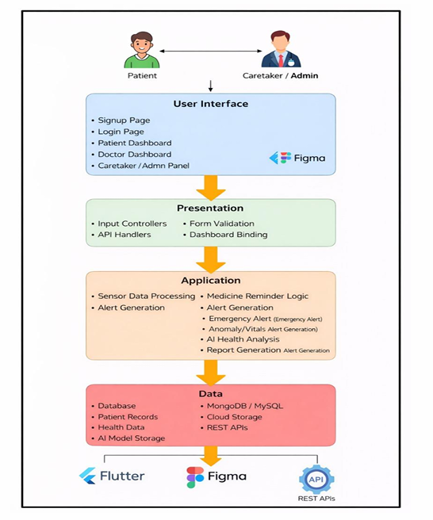

3.3. Class Diagram: The class diagram describes the attributes and operations of a class and the constraints imposed on the system. The class diagrams are widely used in the modeling of object oriented systems because they are the only UML diagrams, which can be mapped directly with object-oriented languages:
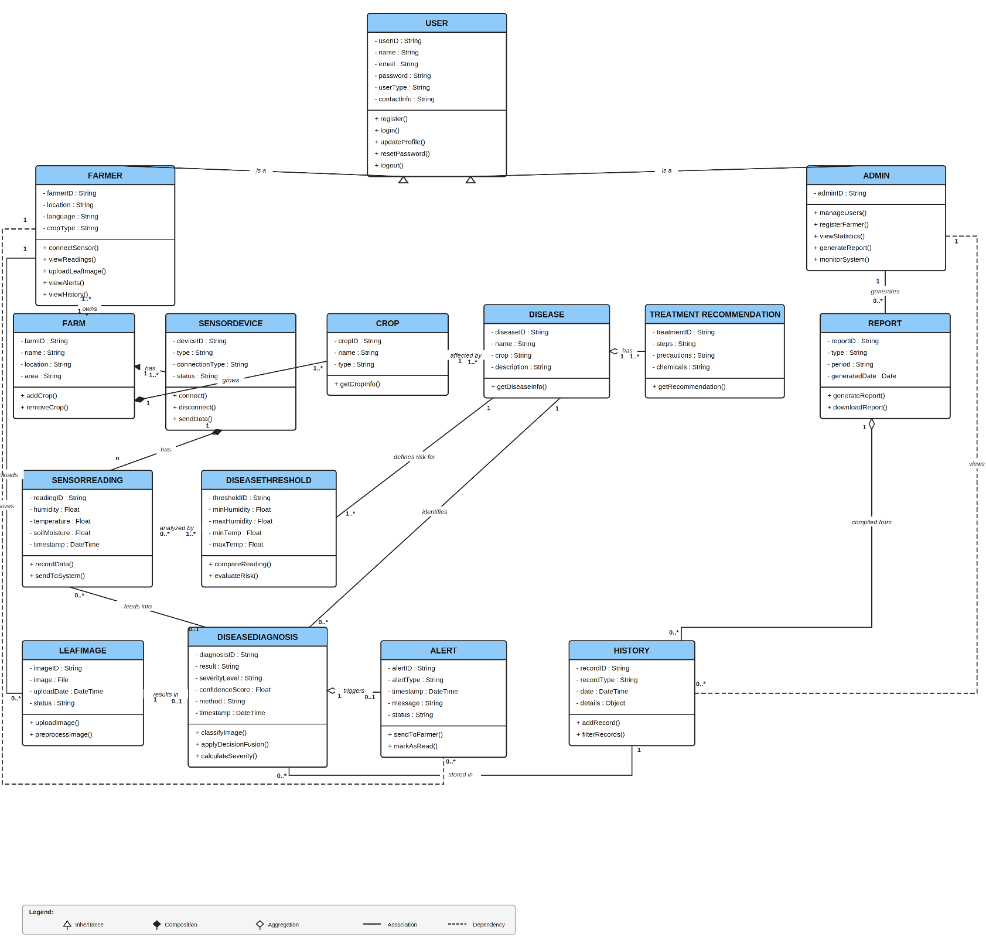

User The User class represents all types of system users, including Farmers and Admins. It contains common attributes such as userID, name, email, password, and userType. Major responsibilities include:
- Registering a new account
- Logging into the system
- Updating profile information
- Resetting the password and logging out This class provides the core identity and authentication functionality for all other modules.
Farmer The Farmer class stores all farmer-specific information such as location, language, and cropType. Farmers interact with the IoT sensor devices and the AI disease confirmation module. Farmer functionalities include:
- Connecting a sensor
- Viewing sensor readings
- Uploading crop leaf images
- Viewing disease risk alerts and historical data The Farmer class has associations with Farm, Sensor Device, Leaf Image, and Alert.
Admin The Admin class handles the back-end management of the system. Admin responsibilities include:
- Managing farmer accounts
- Monitoring system-wide sensor readings
- Generating regional statistical reports The Admin class has relationships with the User class and oversees overall system control.
Sensor Device The Sensor Device class represents the connected IoT hardware (e.g., DHT11, Soil Moisture sensors). It stores:
- Device ID and type
- Connection method (Wi-Fi/Bluetooth)
- Status Functions include:
- Connecting/disconnecting the device
- Sending continuous environmental data Sensor Device has a direct relationship with the Farm and generates Sensor Readings.
Sensor Reading The Sensor Reading class contains the raw environmental data generated by the sensor device. Attributes include:
- Reading ID and timestamp
- Temperature
- Humidity
- Soil Moisture Responsibilities include recording incoming data and sending data to the rule-based risk engine for analysis.
Disease Threshold The Disease Threshold class stores the region-specific environmental rules for Punjab crops. Attributes include:
- Minimum and maximum temperature boundaries
- Minimum and maximum humidity boundaries Responsibilities include comparing real-time sensor readings against these thresholds to evaluate disease risk before symptoms appear.
Disease Diagnosis The Disease Diagnosis class represents the artificial intelligence (CNN) and decision fusion module. Attributes include:
- Diagnosis ID
- Result (Disease name)
- Severity level and confidence score Functions:
- Classifying uploaded leaf images
- Calculating severity It connects to both Sensor Readings and Leaf Images to produce final results and trigger alerts.
Alert The Alert class stores notifications triggered by high disease risk or confirmed diagnoses. Attributes include:
- Alert type
- Message
- Timestamp
- Status Responsibilities:
- Sending early warning alerts to Farmers
- Logging notifications for Admin viewing
Report The Report class generates structured statistical summaries based on collected farm data. Data includes:
- Report type and period
- Generated date Major functions include generating and downloading reports. It is primarily utilized by the Admin.

3.4. Sequence Diagram:
Sequence Diagrams model the flow of logic within your system in a visual manner, enabling you both to document and validate your logic. They are commonly used for both analysis and design purposes to show how objects interact over time.
3.4.1. Farmer: This Sequence diagram shows the flow of Farmer actions, how they interact with the system, and how they perform general operations such as Register, Login, Update Profile, Connect Sensors, View Sensor Readings, Upload Leaf Images for CNN Verification, Receive Early Alerts, and Logout.
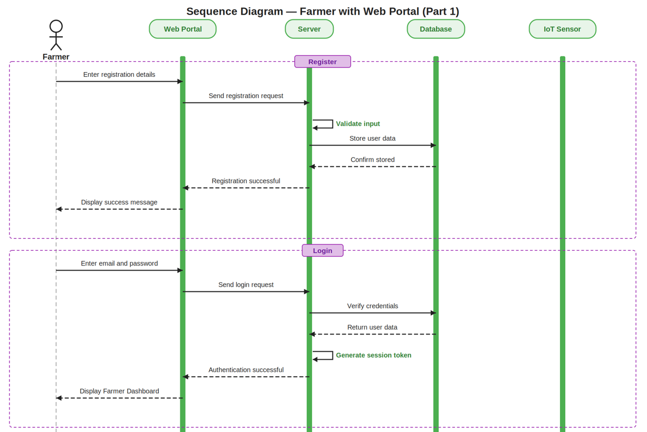

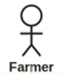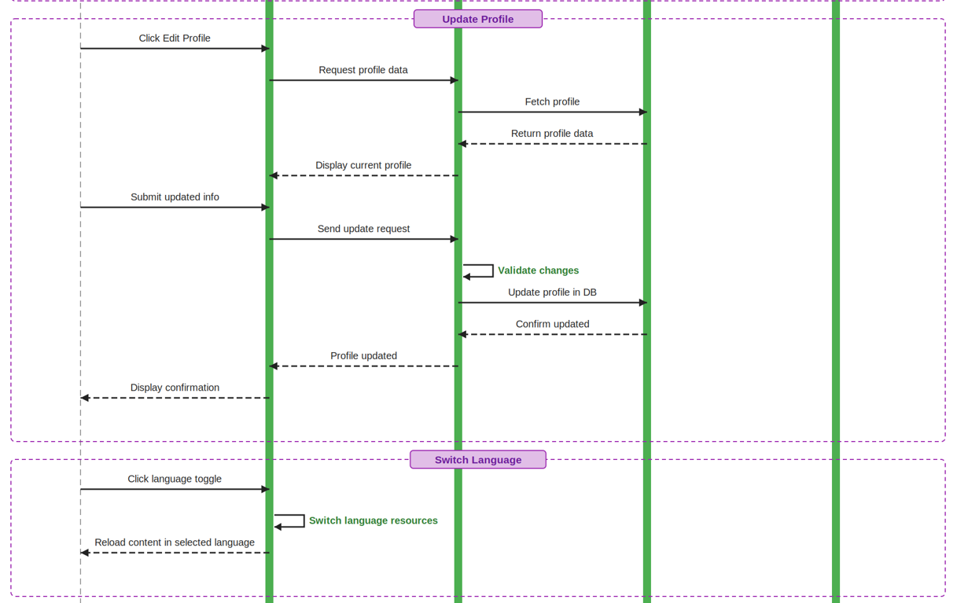

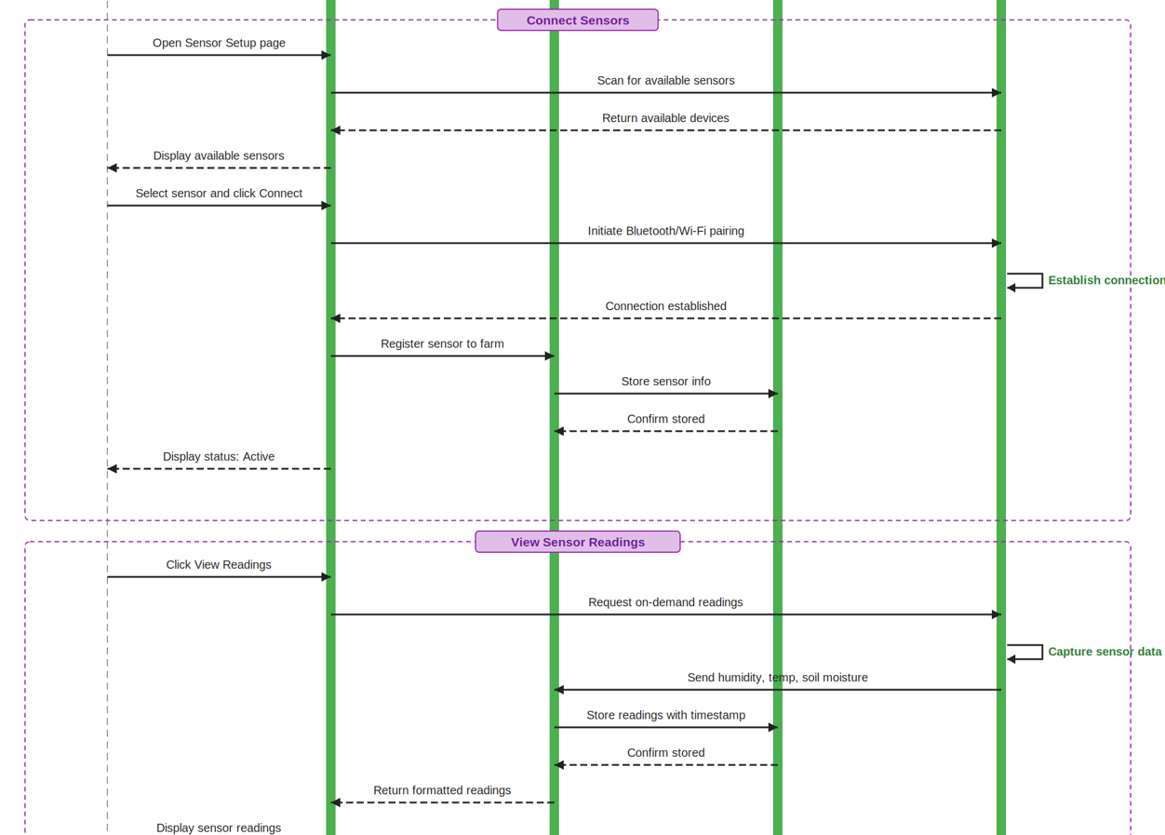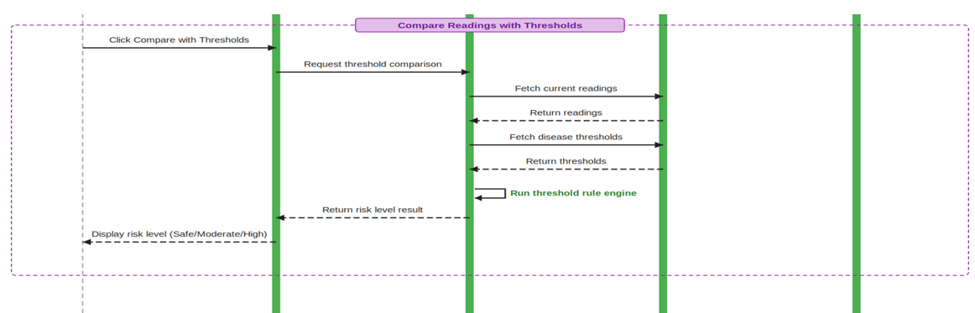

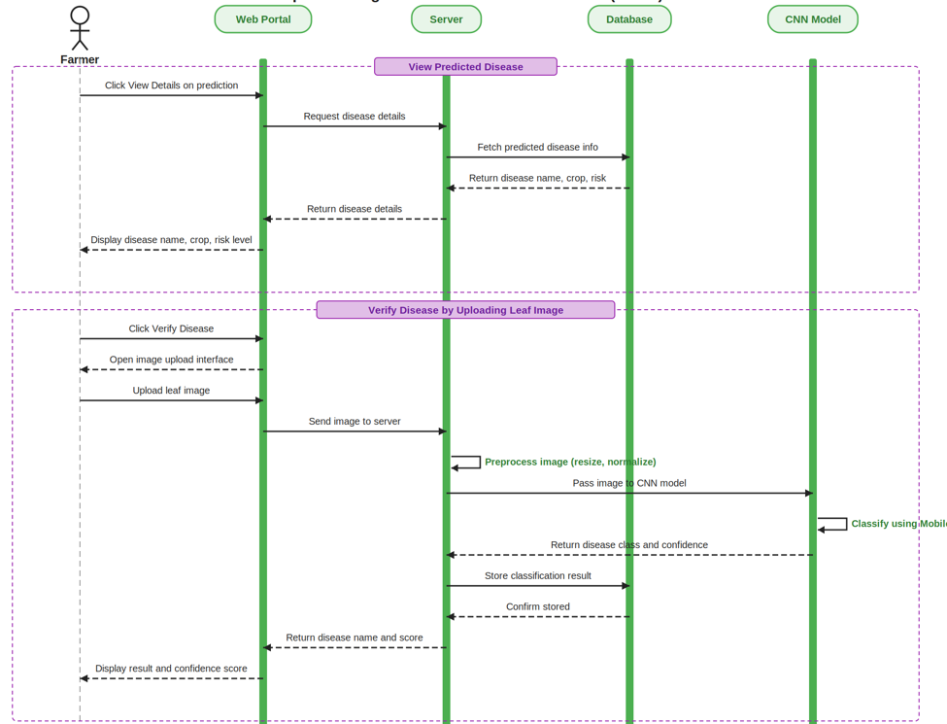

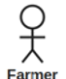
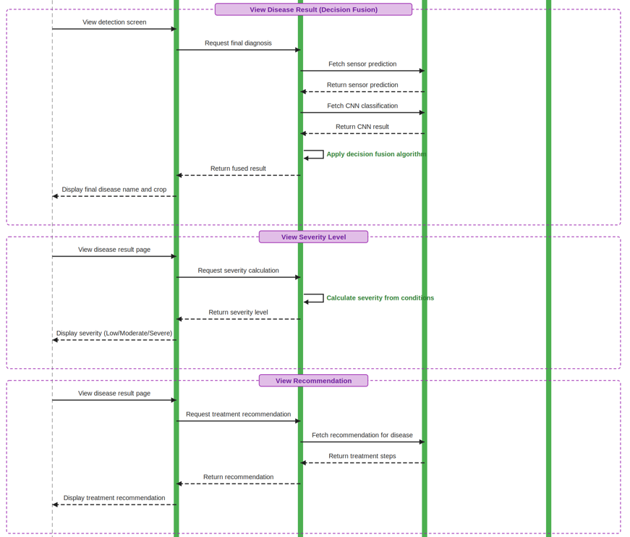

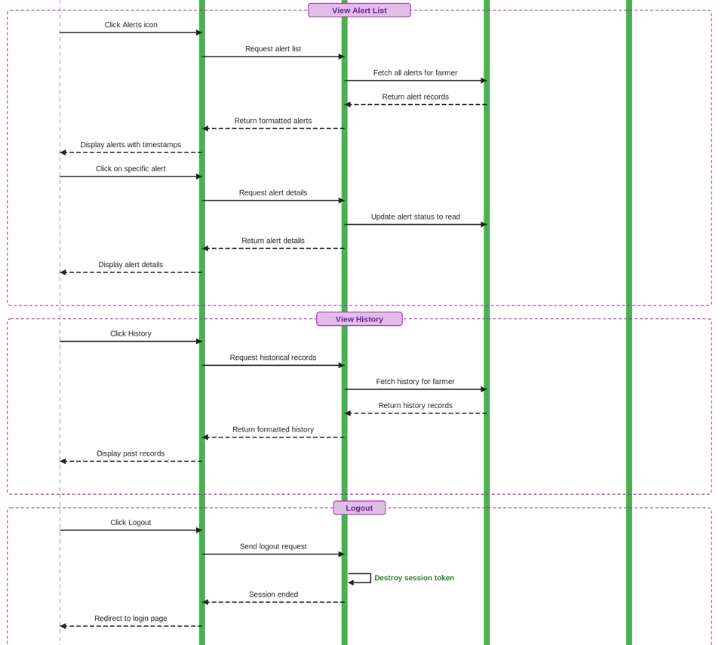

3.4.2. Admin: This Sequence diagram shows the flow of the Admin's actions, how they interact with the system, and how they perform general operations such as Register, Login, Update Profile, View All Sensor Readings across registered farms, View All Alerts, Filter Data, View Statistics, View Disease History, Generate Reports, and Logout.

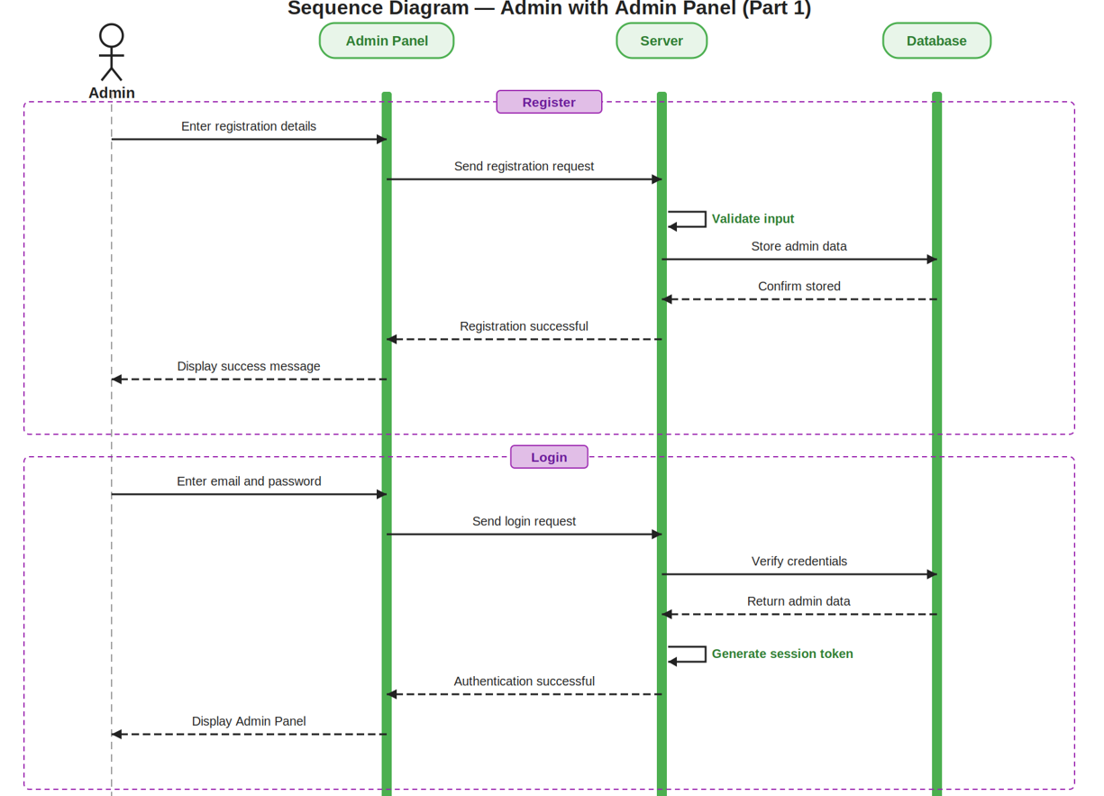

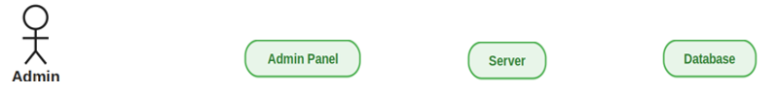
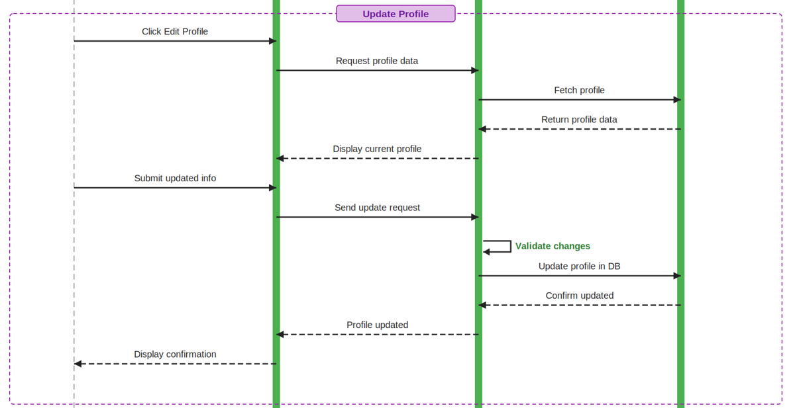
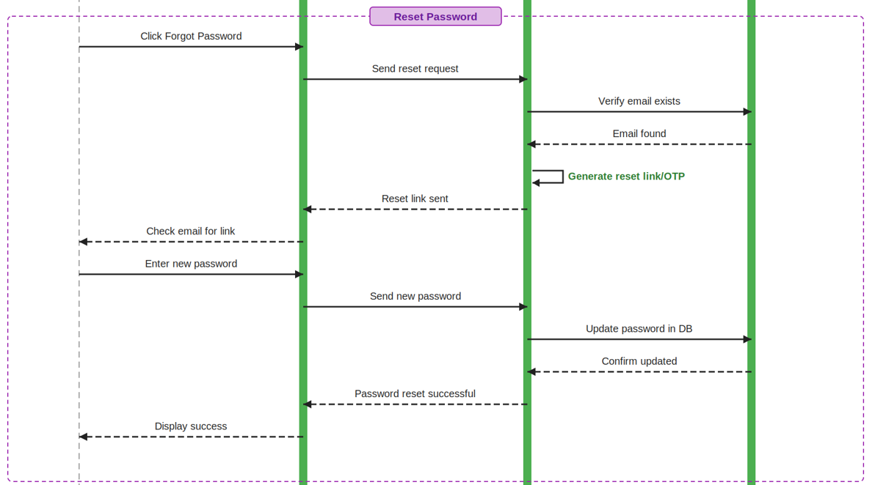
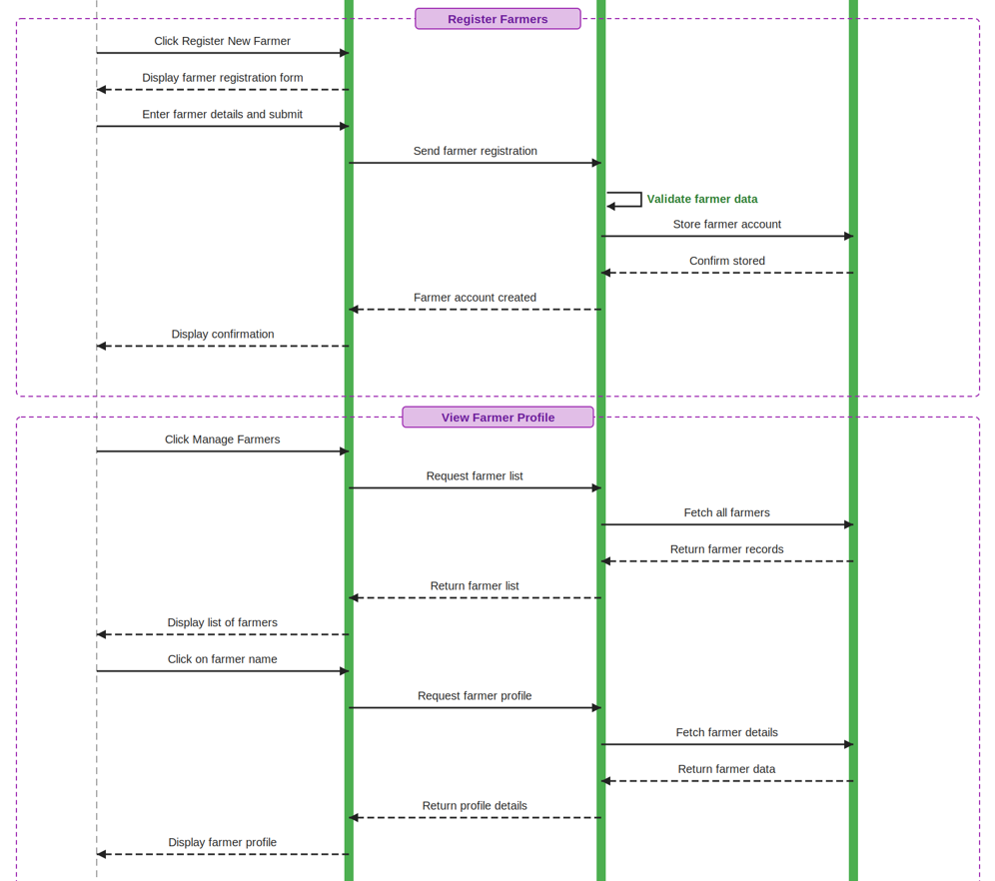

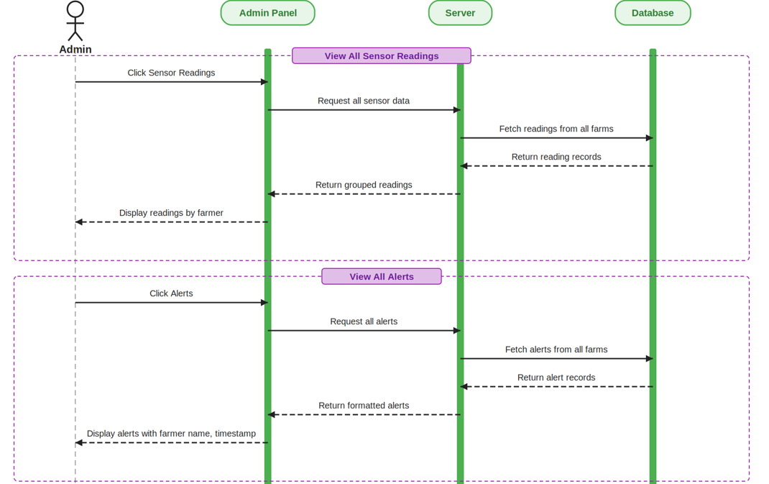

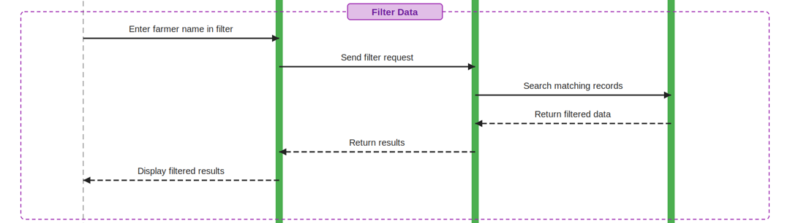

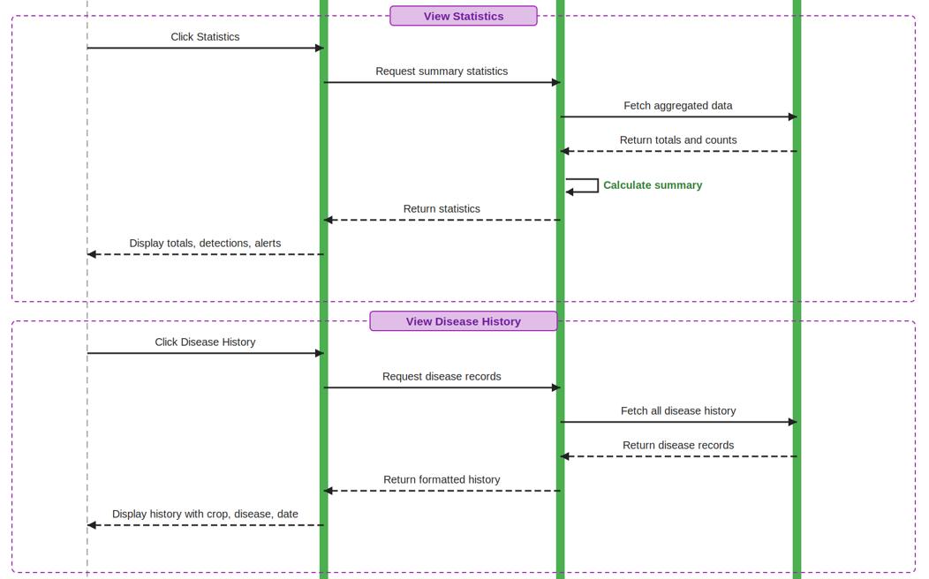

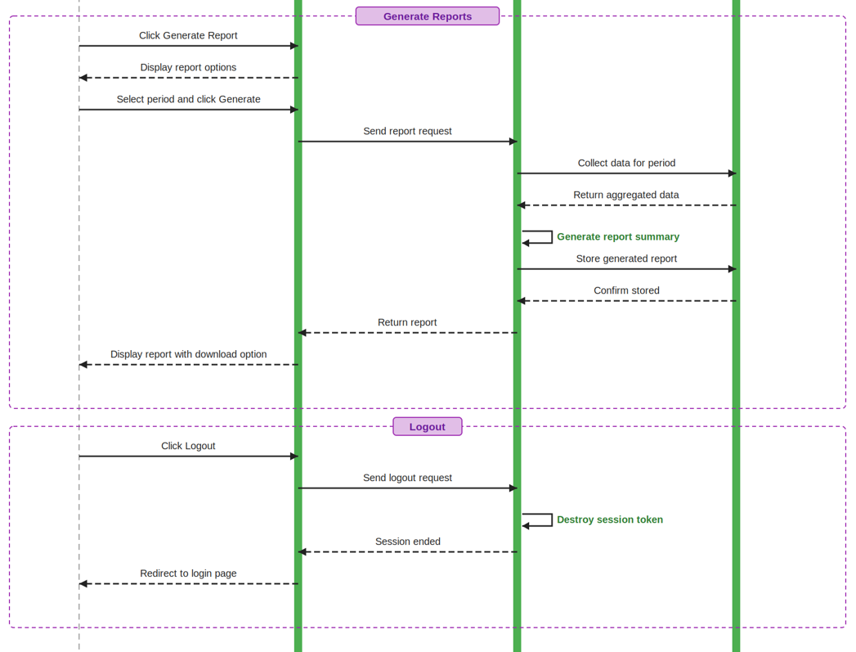

3.5. User Interface Design:

